**Date: 01/12/2017**

**Document Version: 1.0.0**

**Dart Installation on Windows**

Two favourable options are available:

1. Windows Community Installer is available on: [**http://www.gekorm.com/dart-windows/**](http://www.gekorm.com/dart-windows/)
2. Second option is Installation using Chocolatey (a package manager for windows):

choco install dart-sdk -version <version>

choco install dartium -version <version>

**Pre-requisite:** dart-sdk should be handy before using chocolatey. Available on: [**https://www.dartlang.org/tools/sdk**](https://www.dartlang.org/tools/sdk)

After installation is completed check by writing dart at command line, should be:

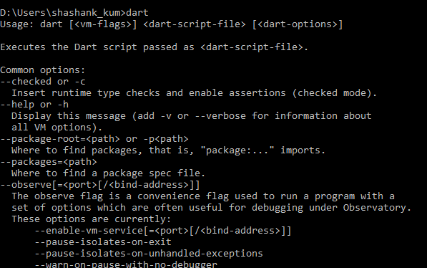

**IDE for Dart Application development**

1. Web Storm (Recommended) – Licensed.
2. IntelliJ IDEA (Recommended)– Licensed.
3. The following Dart plugins are unsupported and available as open source:
   1. Atom
   2. Emacs
   3. Sublime Text 3
   4. Vim
   5. Visual Studio Code
4. For managing Dart Packages, we require Pub package manager (pre-installed with the SDK).

**ANGULARDART**